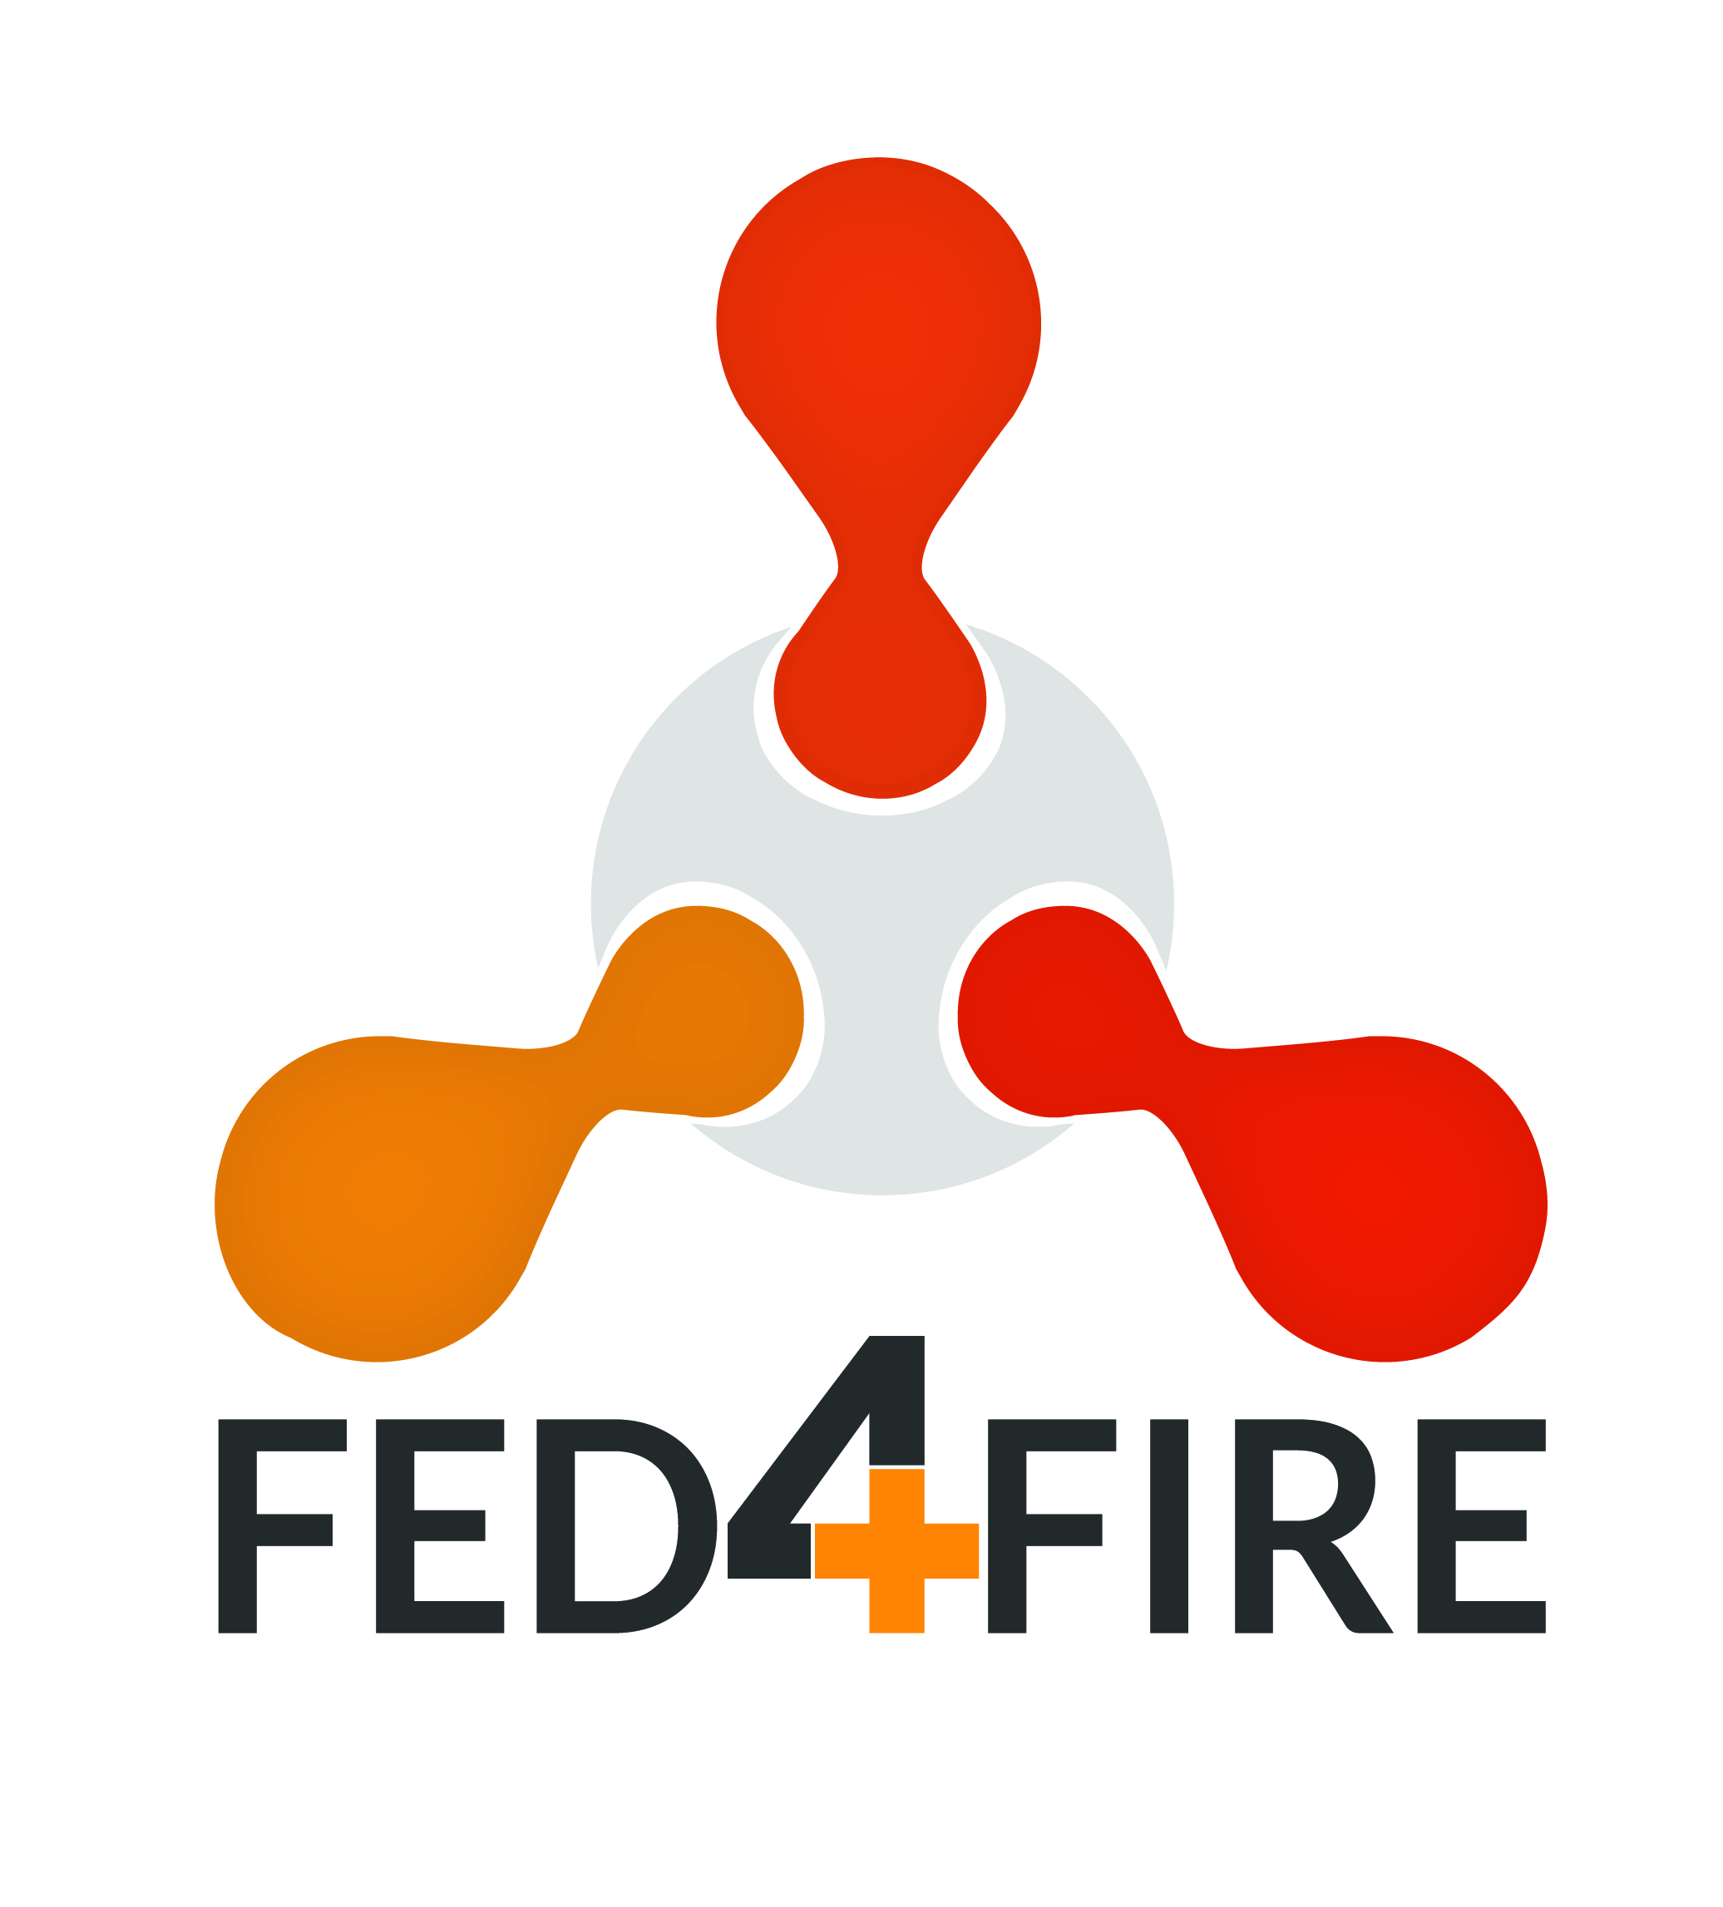 |  |  | 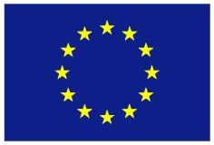

Fed4FIRE+ Experiment Report

Full title of your project
Acronym of your proposal (optional)
Date of preparation of your proposal: xx/yy/20xx
Version number (optional):

Your organisation name: Your organisation name
Your organisation address: Your organisation address
Name of the coordinating person: Name of the coordinating person
Coordinator telephone number: Coordinator telephone number
Coordinator email: Coordinator email
(this will be the email address to which the Acknowledgement of Receipt will be sent)

- Project Summary
This section provides an executive summary of the experiment objectives, implementation and main results. Remark: The information in this section will be used in public documents and reports by the Fed4FIRE+ consortium. The length of this section is restricted to 1 page.

- Detailed Description
This section describes the details on the experiment and provides information as you have been collecting this from your point of view and from your business.
- Concept, Objectives, Set-up and Background
There is no page limit for this section as you are invited to describe the concept, objectives and setup in as much detail as you wish to do. Please also include graphs and figures were needed.
    - Concept & objectives
Describe in detail the concept and objectives of your experiment.
    - Set-up of the experiment
Describe in detail the set-up of your experiment. What was the technical design of the experiment? Please include a general overview figure to explain the set-up.
    - Background / Motivation
Situate this experiment in your business or research activity. Why did you want to execute this experiment? How did this experiment fit within the strategy of your company / institution?
- Technical Results & Lessons learned
Describe in detail the technical results of your experiment and the lessons learned.
There is no page limit for this section as you are invited to describe the concept, objectives and setup in as much detail as you wish to do. Please also include graphs and figures were needed.
- Business impact
Describe in detail how this experiment may impact your business and product development.
    - Value perceived
What is the value you have perceived from this experiment (return on investment)?
E.g. gained knowledge; acquired new competences; practical implementation solutions such as scalability, reliability, interoperability; new ideas for experiments/products; etc.
What was the direct or indirect value for your company / institution? What is the time frame this value could be incorporated within your current product(s) range or technical solution? Could you apply your results also to other scenarios, products, industries?
If no federation of testbed infrastructure would be available, how would this have affected your product / solution? What would have been the value of your product / solution if the experiment was not executed within Fed4FIRE+? What problems could have occurred?
Are there any follow-up activities planned by your company/institution? New projects or funding thanks to this experiment? Do you intend to use Fed4FIRE+ facilities again in the future?

    - Funding
Was the allocated budget related to the experiment to be conducted high enough (to execute the experiment, in relation to the value perceived, etc.)?
Did you receive other funding for executing this experiment besides the money from the Fed4FIRE+ Open Call (e.g. internal, national, etc.)?
Would you (have) execute(d) the experiment without receiving any external funding?
Would you even consider to pay for running such an experiment? If so, what do you see as most valuable component(s) to pay for (resources, support, etc.)?

- Feedback to Fed4FIRE+
This section contains valuable information for the Fed4FIRE+ consortium and describes your experiences by running your experiment on the available testbeds. Note that the production of this feedback is one of the key motivations for the existence of the Fed4FIRE+ Open Calls.
- Resources & tools used
    - Resources
Describe the testbeds you have been using and specify the resources used.
Wired networking testbeds |  |  | Used? | Specify the type and amount of the resources used
 | Virtual Wall (imec)
 | PlanetLab Europe (UPMC)
 | PL-LAB (PSNC)
 | Geant Testbed as a Service (GTS) (Nordunet)
Wireless/5G/IoT testbeds
 | w-iLab.t (imec)
 | Portable wireless testbed (imec)
 | CityLab (imec)
 | NITOS (UTH)
 | Netmode (NTUA)
 | SmartSantander (UC)
 | Triangle/PerformLTE (UMA)
 | IRIS (TCD)
 | LOG-a-TEC (JSI)
 | R2lab (Inria)
 | IoTLab (Mandat)
OpenFlow testbeds
 | i2CAT OFELIA island
 | NITOS (UTH)
 | Virtual Wall (imec)
 | Grid5000 (Inria)
Cloud computing testbed
 | Virtual Wall (including GPUlab) (imec)
 | Exogeni (UvA)
 | Grid5000 (Inria)
Other (big data, AI, machine learning, …)
 | Tengu – big data (imec)
 | GPULab (imec)

Did you make use of all requested testbed infrastructure resources, as specified in your Open Call proposal? If not, please explain.
What was the ratio between time reserved vs time actually used for each resource? Why does it differ that much (e.g. for interference reasons, other)?
    - Tools
Describe in detail the tools you have been using, resources used, how many nodes, etc.
Tools | Used? | Please indicate your experience with the tools. What were the positive aspects? What didn’t work?
JFed
JFed command Line (CLI)
Omni
OMF
NEPI
OML
Please list below other tools used

- Feedback based on design/set-up/running your experiment on Fed4FIRE+
Describe in detail your experiences concerning the procedure and administration, set-up, Fed4FIRE+ portfolio, documentation and support, experimentation environment, and experimentation execution and results. This feedback will help us for future improvement.
    - Procedure / Administration
How do you rate the level of work for administration / feedback / writing documents / attending conference calls or meetings compared to the timeframe of the experiment?
    - Setup of the experiment
How much effort was required to set up and run the experiment for the first time? Did you need to install additional components before you were able to execute the experiment (e.g. install hardware / software components)?
How do your rate the experience as user that you only had to deal with a single service provider (i.e. single point of contact and service) instead of dealing with each testbed itself?
    - Fed4FIRE+ portfolio
Was the current portfolio of testbeds provided by the federation, with access to a large set of different technologies (sensors, computing, network, etc.) provided by a large amount of testbeds, sufficient to run your experiment?
Was the technical offering in line with the expectations? What were the positive and negative aspects? Which requirements could not be fulfilled?
Could you easily access the requested testbed infrastructures?
Could you make use of all requested resources at the different testbeds as was proposed in the description of the experiment? If not, how many times did this fail? What were the main reasons it failed (e.g. timing constraints, technical failures, etc.)?
Did you use a lot the combination of resources over different testbeds? Did it all work out nicely? Were they interoperable?
    - Documentation and support
Was the documentation provided helpful for setting up and running the experiment? Was it complete? What was missing? What could be updated/extended?
Did you make use of the first level support dashboard?
Did you contact the individual testbeds for dedicated technical questions?

    - Experiment environment
Was the environment trustworthy enough for your experiments (in terms of data protection, privacy guarantees of yourself and your experiment)?
Did you have enough control of the environment to repeat the experiment in an easy manner?
Did you experience that the Fed4FIRE+ environment is unique for experimentation and goes beyond the lab environment and enables real world implementation?
Did you share your experiment and/or results with a wider community of experimenters (e.g. for greater impact of results, shared dissemination, possibility to share experience and knowledge with other experimenters)? If not, would you consider this in the future?
    - Experiment execution and results
Did you have enough time to conduct the experiment?
Were the results below / in line with / exceeding your initial goals and expectations?
What were the hurdles / bottlenecks? What could not be executed? Was this due to technical limits? Would the federation or the individual testbeds be able to help you solving this problem in the future?
    - Other feedback
If you have other feedback or comments not discussed before related to the design, set-up and execution of your experiment, please note them below.
- Why Fed4FIRE+ was useful to you
Describe why you chose Fed4FIRE+ for your experiment, which components were perceived as most valuable for the federation, and your opinion what you would like to have had, what should be changed or was missing.
    - Execution of the experiment
Why did you choose Fed4FIRE+ for your experiment? Was it the availability of budget, easy procedure, possibility to combine different (geographically spread) facilities, access to resources that otherwise would not be affordable, availability of tools, etc.? Please specify in detail.
Could you have conducted the experiment at a commercially available testbed infrastructure?
    - Added value of Fed4FIRE+
Which components did you see as highly valuable for the federation (e.g. combining infrastructures, diversity of available resources, tools offered, support and documentation, easy setup of experiments, etc.)? Please rank them in order of importance.
Which of these tools and components should the federation at least offer to allow experimentation without funding?
    - What is missing from your perspective?
What would you have liked to have had within Fed4FIRE+ (tools, APIs, scripts, etc.)? Which tools and procedures should be adapted? What functionality did you really miss?
Which (types of) testbed infrastructures (and resources) would have been very valuable for you as an experimenter within the Fed4FIRE+ consortium?
Is there any other kind of support that you would expect from the federation, which is not available today e.g. some kind of consultancy service that can guide you through every step of the process of transforming your idea into an actual successful experiment and eventually helping you to understand the obtained results?

    - Other feedback
If you have further feedback or comments not discussed before how Fed4FIRE+ was useful to you, please note them below.
    - Quote
We would also like to have a quote we could use for further dissemination activities. Please complete the following sentence.
Thanks to the experiment I conducted within Fed4FIRE+ ...

